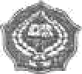Universitas Islam Negeri Sunan Kolijaga FM-UINSK-B\-05-02/RO

KARTU BIMBINGAN TESIS/TUGAS AKHIR

|  |  |  |
| --- | --- | --- |
| Nama mahasiswa | : |  |
| NIM | : |  |
| Pembimbing | : |  |
| Judul | : |  |
| Fakultas | : |  |
| Jurusan/Program Studi | : |  |

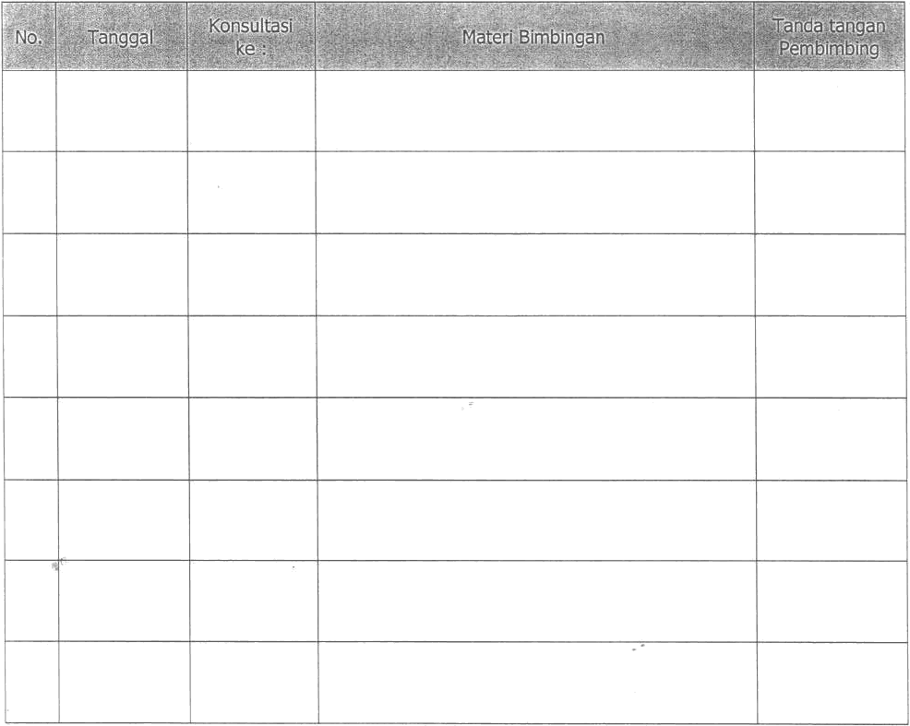

Yogyakarta, „

Pembimbing

NIP.